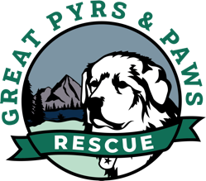

Owner Surrender Assistance Program

Owner surrender to adoption program

- Dog is in a region where GPPR volunteer can assess the dog, TX, ID, WA, OR and surrounding areas
- Dog must be FULLY vetted, S/N, UTD on all vaccines, HW treatment
- Any behavioral issues to be addressed with a trainer or behaviorist prior to surrender and information is provided to potential adopter.
- Owner donates $100 to the rescue that is non-refundable
- Owner must sign a surrender form and agreement to foster until dog is adopted.
- Owner signs a contract saying they agree to not request the dog back once adopted out.
- We add the dog in our rescue program including postings on Petfinder and Adopt a Pet then advertised on our social media. Incoming applications are processed by our adoption counselor and volunteers help the surrendering owner to interview potential applicants.
- If a rescue foster comes available, we prioritize by surrender date and goodness of fit with foster family
- Adopter donates $100 to rescue
- Adopter figures out transport (GPPR volunteers can help between states)
- No returns to the rescue for refunds

